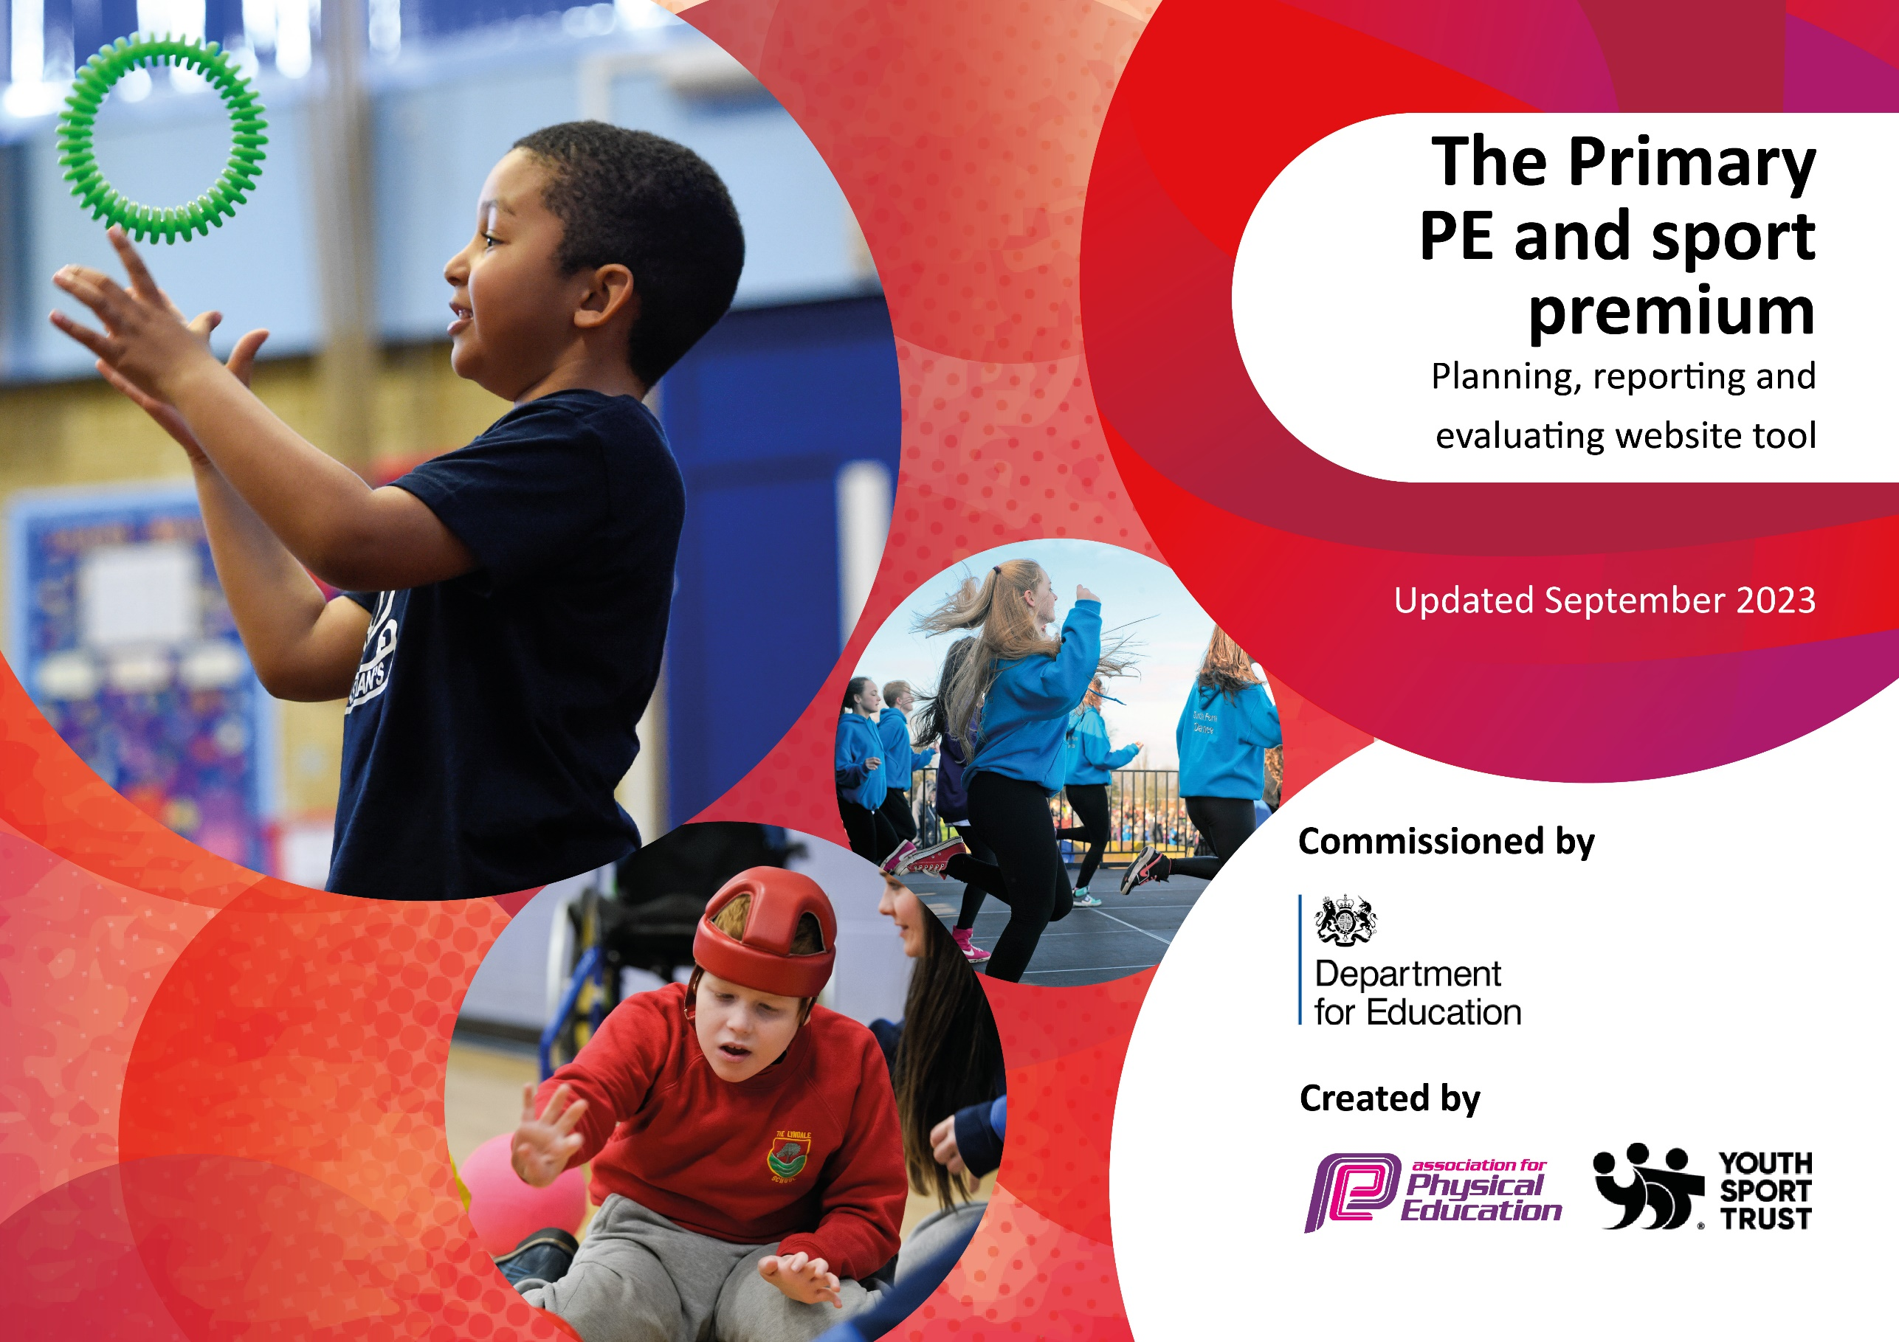

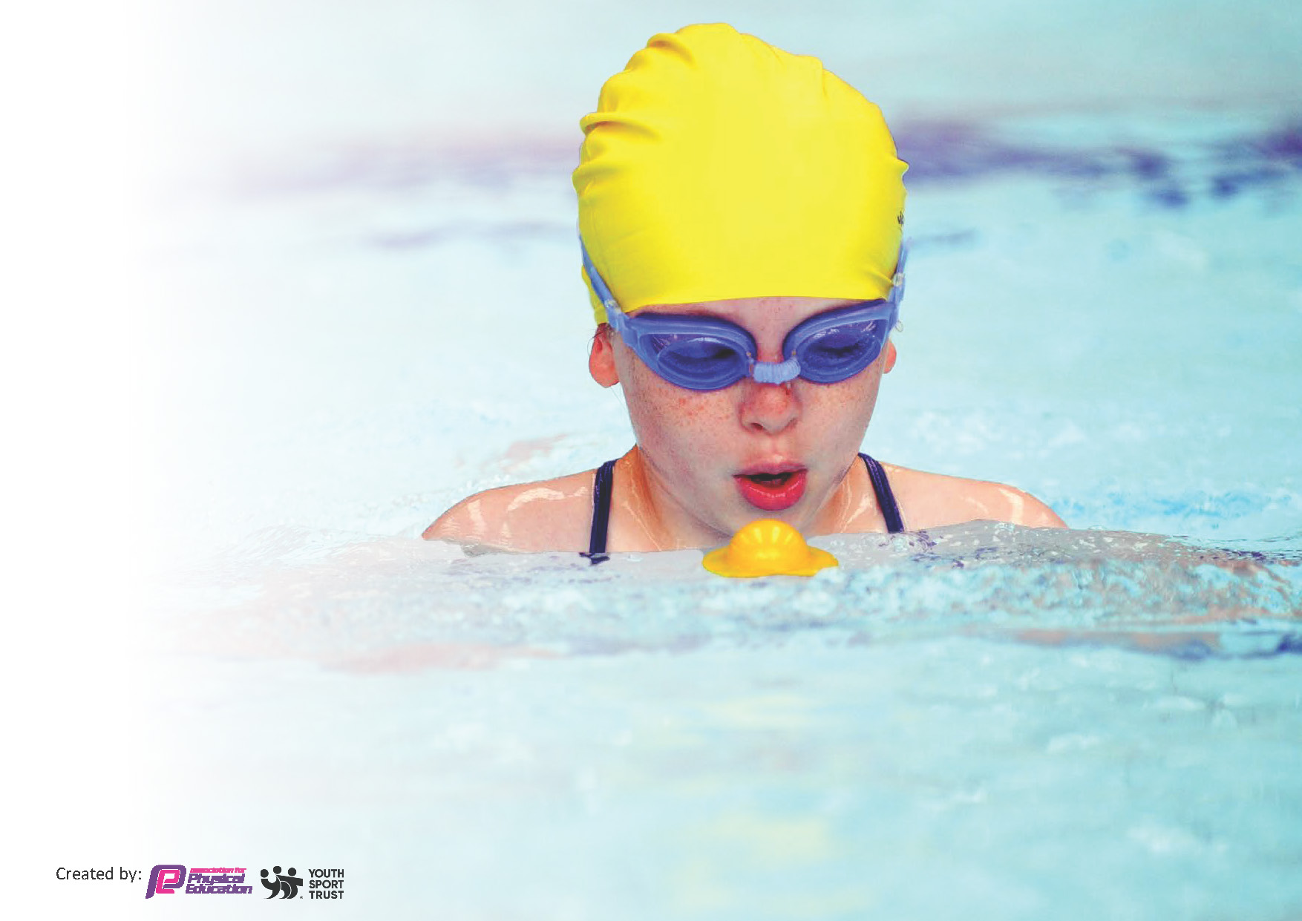
This template can be used for multiple purposes:
by:
- It enables schools to effectively plan their use of the Primary PE and sport premium
- It helps schools to meet the requirements (as set out in guidance) to publish information on their Primary PE and sport premium
- It will be an effective document to support Ofsted inspections enabling schools to evidence progress in Physical Education (PE) and evidence swimming attainment, which forms part of the PE National Curriculum. We would recommend schools consider
the Intent, Implementation and Impact of any spend, as examined within the Education Inspection Framework.

It is important that your grant is used effectively and based on school need.

Schools must use the funding to make additional and sustainable
improvements to the quality of the PE, School Sport and Physical Activity (PESSPA)
they offer. This means that you should use the Primary PE and sport premium to:

- Build capacity and capability within the school to ensure that improvements made now will benefit pupils joining the school in future years
- Develop or add to the PESSPA activities that your school already offers.

The Primary PE and sport premium should not be used to fund capital spend projects; the school’s core budget should fund these. Further detail on capital expenditure can be found in the updated Primary PE and sport premium guidance.

The Primary PE and sport premium guidance, outlines 5 key priorities that funding should be used towards. It is not

necessary that spending has to meet all the key priorities, you should select the priorities that you aim to use any funding towards.

Although completing this template is not a requirement for schools, schools are required to publish details of how they spend this funding. Schools must also outline what the impact this funding has had on pupils’ PE and sport participation and attainment and how any spending will be sustainable in the future. All funding must be spent by 31st July 2024.

The Department for Education has worked closely with the Association for Physical Education (afPE) and the Youth Sport Trust (YST) to develop this template and encourages schools to use it. This template is an effective way of meeting the reporting requirements of the Primary PE and sport premium.
Review of last year’s spend and key achievements (2022/2023)

We recommend you start by reflecting on the impact of current provision and reviewing your previous spend.

Activity/Action | Impact | Comments
Increase the numbers of pupils engaging in physical activity and play during unstructured times.  To develop active breaks (YST) throughout school to improve well being and activity levels of all pupils.  Pupils are actively encouraged to take on leadership / volunteer roles to support the delivery of sport and physical activity across the school.  To increase staff confidence, knowledge and skills through having the weekly support of a highly experience PE teacher  Pupils will engage in a range of new physical activities that can be offered throughout lesson times and enrichment  An increasing school offer that focusses on pupil’s participation in competitive sport. | Sports leaders and staff have offered structured active breaks and this has had a positive effect on the students health and engagement during parts of the day  Sports leaders have supported and coached their younger peers  A cohort of sport leaders has now been established and they have build the expertise to led in school  New resources and equipment has allowed to students build confidence and increase their participate in sport in and out of lessons  Most students and parents experienced their first ever sport s day. All students took part and they enjoyed competing in house for competition  Many students experienced participating in external events for the first and this increased their confidence and self-worth | Next steps: Sports leader to teach other students how run the active breaks  Next steps: For sports leaders to coach external students  Next steps: To develop their leadership skills by participating on external projects and SEND festivals  Next steps: For students to experience a range of new sports and equipment  Next steps: To build on this by intruding the new reward system in lessons and a sports day on a larger scale  To continue to participate in external events

Key priorities and Planning
This planning template will allow schools to accurately plan their spending.

Action – what are you planning to do | Who does this action impact? | Key indicator to meet | Impacts and how sustainability will be achieved? | Cost linked to the action
CPD for TA staff to support in PE lessons  Increase the numbers of pupils engaging in physical activity and play during unstructured times.  An after-school football club is established and accessed regularly by a range of pupils  There are a range of additional opportunities during the school day and via the curriculum for pupils to be engaged in physical activity | TA staff and students  The students  The students and staff  Teachers, TA’s and students | Key Indicator 1: Increased confidence, knowledge, and skills of all staff in teaching PE and sport.  Key Indicator 2: The engagement of all pupils in regular physical activity  Key Indicator 2: The engagement of all pupils in regular physical activity  Key indicator 3: The profile of PESSPA being raised across the school as a tool for whole school improvement | A bespoke personal development training for TA to be given the skills/tools to support expertly in PE lessons and sporting activities  Invest in a range of engaging outdoor gym/active equipment to support students physical and mental well being at social times and active/sensory breaks  An after-school football club is established and offered to students at least once a week  Class teachers plan and use a range of physical activities through their teaching, including, Active Phonics, Outdoor Learning, Wake Up, Shake UP (L1) and brain breaks. | £1000  £10000  £500  £200

Pupils are actively encouraged to take on leadership / volunteer roles to support the delivery of sport and physical activity across the school.  Using the YST research on sports sanctuaries pupils to have access to sports equipment that encourages pupils to self-regulate through movement.  Students to be given the opportunity to participate in external YST SEND festivals and events  An increasing school offer that focusses on pupil’s participation in competitive sport. | The students  Staff and students  The students  Staff and students | Key indicator 3: The profile of PESSPA being raised across the school as a tool for whole school improvement  Key indicator 4: Broader experience of a range of sports and activities offered to all pupils  Key indicator 4: Broader experience of a range of sports and activities offered to all pupils  Key indicator 5: Increased participation in competitive sport | Student sport leaders to support staff in purchasing new sports sanctuary equipment Sports leaders will be responsible for the organisation and disruption on the equipment during break and dinner times  Staff to explore a range of options that will benefit pupils physically and will offer an area to self-regulate.  Students to improve the confidence and self-esteem  Pupils to participate in house and cross school competitions.  Annual Family Sports Day and rewards using world class sporting facilities | £500  £700  £2000  £500

Key achievements 2023-2024
This template will be completed at the end of the academic year and will showcase the key achievements schools have made with their Primary PE and sport premium spending.

Activity/Action | Impact | Comments

Swimming Data
Meeting National Curriculum requirements for swimming and water safety.
Priority should always be given to ensuring that pupils can perform safe self-rescue even if they do not fully meet the first two requirements of the National Curriculum programme of study

Question | Stats: | Further context  Relative to local challenges
What percentage of your current Year 6 cohort can swim competently, confidently and proficiently over a distance of at least 25 metres? | 25% | Students are participating in the school swimming service for the first time with the main aim to teach the students swim and achieve the age-related milestones
What percentage of your current Year 6 cohort can use a range of strokes effectively [for example, front crawl, backstroke, and breaststroke]? | 13% | Only 13% of students in the Y6 cohort can perform these strokes. Students are participating in the school swimming service for the first time with one of the aims to teach them the range of strokes.

What percentage of your current Year 6 cohort are able to perform safe self-rescue in different water-based situations? | 0% | All the parents of the students in the Y6 cohort stated in a questionnaire that they can’t perform self-rescue. This will be address in the school swimming service programme.
If your schools swimming data is below national expectation, you can choose to use the Primary PE and sport premium to provide additional top-up sessions for those pupils that did not meet National Curriculum  requirements after the completion of core lessons. Have you done this? | No | We have not used the sport premium to top up sessions as we are a new school and using school swimming service programme for the first time
Have you provided CPD to improve the knowledge and confidence of staff to be able to teach swimming and water safety? | Yes | The school swimming service programme providing online training for this.

Signed off by:

Head Teacher: | Luci Windle
Subject Leader or the individual responsible for the Primary PE and sport premium: | Andy Pleass, Lead teacher of PE
Governor: | Jim McIntosh
Date: | 7/11/24

